*Measuring the Effectiveness of Digital Inclusion Approaches (MEDIA)*

Evaluating the Impact of the Affordable Connectivity Program

DRAFT #1 (March 2024)

1. Background

The Affordable Connectivity Program (ACP) is a means-tested federal program launched in January 2022 to support broadband connectivity among low-income households. The program received a one-time appropriation of $14.2 billion from the Infrastructure Investment and Jobs Act (IIJA) of 2021. These funds are expected to be depleted by May 2024 and, at the time of writing (February 2024), there is no indication that Congress will renew funding for ACP. The likely expiration of the ACP benefit, the largest ever connectivity support program for low-income households, invites a discussion about the impact of the program and what alternative policy mechanisms are available to continue promoting digital equity.

ACP offers two types of support: 1) a service discount of up to $30/month for residential broadband service (which increases to $75/month in Tribal areas), and 2) a one-time discount of up to $100 towards the purchase of a device (laptop, desktop computer, or tablet). The service discount can be applied to either fixed or mobile services; however, mobile devices (“smartphones”) are explicitly excluded from the device discount program, suggesting that a key goal of ACP is to promote the adoption of high-speed fixed broadband (such as cable, DSL or fiber service). By the end of 2023, about 22.6M households were enrolled in ACP, with about 45% subscribing to fixed services and 55% to mobile services.

This study offers a preliminary assessment of the ACP’s goal to promote fixed broadband among low-income households. It combines broadband deployment data from the FCC with USAC data about ACP subscriptions and demographic data from the Census Bureau’s American Community Survey (ACS). Considering the relatively short time span of the ACP program and the time lag in the availability of data, the results of the study are necessarily preliminary. At the same time, given the likely expiration of broadband support for over 22M of the most vulnerable households, the need for evidence that supports discussions about the future of universal service is urgent.

1. Data and Methods

The challenge involved in evaluating the impact of the ACP program is well understood in the program evaluation literature, and involves identifying a suitable counterfactual. In other words, what would have happened to broadband adoption among low-income households had the ACP program not been put into place in January 2022? This is particularly challenging in the ACP case, a federal program in which states play a negligible role, because there are no state variations in implementation timing, eligibility requirements or types of service supported (such variations have been exploited in program evaluations of Lifeline for example).[1]

This study addresses this challenge by identifying low-income areas (counties) where the impact of the ACP program is expected to be minimal due to supply-side constraints. In other words, ACP is a demand support program whose impact is conditional on the adequate availability of high-speed broadband services for low-income households. Therefore, in counties where such supply is lacking, the potential impact of the program can be expected to be very limited. Using the most recent network deployment data from the FCC, we identify low-income counties where less than half of the residential locations are served by fixed broadband - that is, by cable, DSL, fiber or fixed wireless service with minimum speeds of 25/3Mbps.[2] These counties are heretofore referred as “underserved.”

It is important to note that other types of ACP-supported services are likely to be available in these counties, notably mobile broadband services. The premise of this study, however, is that the impact of ACP on the adoption of fixed broadband in underserved counties can be expected to be minimal due to the limited availability of wireline services. As such, these counties can be used as counterfactuals (or “control” units) to evaluate the impact of the ACP program in low-income counties where ACP-supported wireline services are more readily available.

To identify low-income counties where a majority of households qualifies for ACP, the study uses a threshold of $50,000/year in median household income. This threshold is a necessary approximation, since a precise estimation of eligibility would require the use of ACS microdata, which is only available for areas with at least 100,000 residents (called PUMAs). Working at the PUMA level, however, would severely limit our sample given that the vast majority of low-income counties are also low-population counties. In the analysis presented below, we test the sensitivity of our results to other income thresholds, and a more detailed discussion about this income threshold can be found in Appendix A. We also perform a robustness check that involves introducing service availability as a continuous rather than a discrete variable, thus relaxing the distinction between served and underserved counties.

In addition, we offer two different tools that allow readers to explore how different income and served locations thresholds affect the designation of counties as underserved.

1. An [interactive map](https://public.tableau.com/app/profile/arnic7024/viz/UnderservicedCounties/UnderservicedCountiesMap) that includes race/ethnicity and connectivity statistics for counties designated as underserved
2. A [scatterplot](https://public.tableau.com/app/profile/arnic7024/viz/UnderservicedCountiesScatterplot/UnderservicedCountiesScatterplot) showing how selected counties are distributed along median household income and broadband access axes.

A number of data limitations must be noted at the outset. The key metric used to assess the performance of ACP is the share of households where broadband and a computer device (desktop, laptop, or tablet) are present. This data can be found in the ACS 5-year tables for all U.S. counties; however, they represent an average for the entire period (the most recent being 2018-2022). We use these estimates to characterize underserved counties in relation to other counties in the cross-section analysis; however, they cannot be used in panel data models, as these require discrete, non-overlapping data points. For this, we use the ACS 1-year supplemental tables, which are available for areas with at least 20,000 residents. Because of this population threshold, the sample size used in the panel data models is necessarily smaller, and does not include the least populated counties. Finally, Connecticut counties are excluded from the analysis due to differences in the boundaries used by the FCC and the Census Bureau. It is important to note these limitations in the interpretation of results.

1. Characterization of underserved low-income counties

Just over 100 U.S. counties fall under our definition of control units - that is, the median household income is below $50,000/year and fixed broadband is available to fewer than 51% of residential locations. These counties are home to about 1.4M residents who live in approximately 515,000 households. As shown in Figure 1, while these counties are scattered across the U.S., there is a notable concentration in the Southeast region. This concentration is in part due to the income threshold used to identify underserved areas, which results in more counties being concentrated in low-income states such as Alabama, Arkansas, Mississippi and Louisiana. Our [Underserved Counties Dashboard](https://public.tableau.com/app/profile/arnic7024/viz/UnderservicedCounties/UnderservicedCountiesMap) allows for testing how different income and served locations thresholds affect the geographical distribution of counties flagged as underserved.

Figure 1: Underserved low-income counties (median HH income below $50K/year and fewer than 51% units served by fixed broadband at 25/3Mbps).

As expected, these are low-income rural counties, with about 21% of families below the federal poverty line (compared to 12.2% in all other counties). The share of underprivileged racial minorities is also higher, with Blacks representing 22% of residents (compared to 12.4% in all other counties) and Native-Americans representing 5.5% of residents (compared to less than 1% in all other counties).

ACP uptake is lower in underserved counties. As noted above, it is not possible to estimate the number of ACP eligible households at the county level without a very significant reduction in the sample size. The second-best approach is to calculate ACP uptake as the share of ACP recipients relative to total (not just eligible) households. Using this metric, the results indicate that ACP uptake (as of December 2023) is at 25.3% of total households in underserved low-income counties, relative to 31.1% in other low-income counties.

Further, broadband adoption in underserved low-income counties lags behind other low-income counties. The share of households with a broadband connection and a computing device in underserved counties stood at 70% in 2022, compared to 76.2% in other low-income counties. Further centering the analysis on the poorest households reveals the extent of the penalty faced by households living in underserved areas. Overall, the share of households with annual income at or below $35K connected to broadband (of any type) is 64.1%, but drops to 56.6% in underserved counties. In other words, for the poorest households, living in an area with inadequate availability of broadband, and therefore where residents cannot take full advantage of demand-side subsidy programs like ACP, has an outsized impact in the ability to be connected to broadband.

1. Estimating the impact of the ACP program
   1. Cross-section models

This section offers a first-level approximation to the impact of the ACP program by comparing fixed broadband adoption in underserved counties to other low-income counties, while accounting for baseline differences in demographic characteristics known to affect broadband adoption as well as factors that affect the supply of ACP-supported services. The dependent variable in the cross-section models below (Table 1) is the share of households with broadband and a computing device in counties with median household income at or below $50,000/year. Control variables include demographic factors such as median annual household income, population density, median age, race (share of White-only residents), education (share of population 25 years and older with a bachelor’s degree), presence of children in the household, and share of families under the federal poverty line. This data is sourced from the ACS 5-year estimates.

In addition, the model controls for two other factors. The first is the supply of fixed broadband services, which is approximated by the count (number) of fixed service providers in the area. The second factor is the designation as a Tribal county, since households in Tribal areas are eligible for the increased ACP service support of up to $75/month. To test the sensitivity of the results to other income thresholds (and therefore to different sample sizes), Table 1 includes similar models with thresholds at $45,000/year and $55,000/year in median annual household income. To facilitate interpretation of results, the flag for underserved counties is inverted so that the “served” variable indicates counties not flagged as underserved. The estimations are weighed by number of households in each county.

*Table 1: Share of households with broadband and PC, using different income thresholds to identify low-income counties.*

|  |  |  |  |
| --- | --- | --- | --- |
|  | (1) | (2) | (3) |
| VARIABLES | Broadband (any) + PC (<$50K counties) | Broadband (any) + PC (<$45K counties) | Broadband (any) + PC (<$55K counties) |
| **Served (yes=1)** | **0.0310\*\*\*** | **0.0326\*\*\*** | **0.0343\*\*\*** |
|  | **(0.00896)** | **(0.0123)** | **(0.00724)** |
| Median HH income | 3.16e-06*** | 2.78e-06 | 3.16e-06*** |
|  | (9.43e-07) | (1.69e-06) | (7.03e-07) |
| Population density | 2.17e-06*** | 5.95e-05*** | 2.16e-06*** |
|  | (3.15e-07) | (1.79e-05) | (2.70e-07) |
| Rural (yes=1) | -0.0112 | 0.0255 | -0.0201*** |
|  | (0.00921) | (0.0186) | (0.00561) |
| Number of ISPs | 0.000683 | 0.00152 | -1.30e-05 |
|  | (0.000880) | (0.00152) | (0.000775) |
| Tribal (yes=1) | -0.0586*** | -0.0830*** | -0.0338** |
|  | (0.0195) | (0.0241) | (0.0137) |
| White-only residents | 0.0742*** | 0.115*** | 0.0683*** |
|  | (0.0176) | (0.0194) | (0.0140) |
| Bachelor or more | 0.352*** | 0.422*** | 0.254*** |
|  | (0.0842) | (0.103) | (0.0584) |
| Children in the HH | 0.0208 | 0.0793 | 0.0311 |
|  | (0.0874) | (0.117) | (0.0686) |
| Poverty | -0.182* | -0.180 | -0.210** |
|  | (0.0968) | (0.129) | (0.0852) |
| Median age | -0.000363 | -0.00102 | -0.000345 |
|  | (0.000818) | (0.00130) | (0.000679) |
| Constant | 0.522*** | 0.469*** | 0.552*** |
|  | (0.0619) | (0.0985) | (0.0572) |
|  |  |  |  |
| Observations | 602 | 309 | 985 |
| R-squared | 0.482 | 0.411 | 0.492 |

Robust standard errors in parentheses

*** p<0.01, ** p<0.05, * p<0.1

The key result from Table 1 (model 1) is that the countywide availability of ACP-supported fixed services in a county is associated with an increase in the share of households with broadband and a computer of about 3 percentage points, relative to underserved counties where the availability of ACP-supported services is lacking. This represents an increase of about 4.5% relative to the sample average in underserved areas (69.8%). In models 2 and 3 we test for the sensitivity of this result to different income thresholds to identify low-income counties. As expected, the number of observations (counties) increases significantly at $55,000/year, and drops by about half at $45,000/year. However, the coefficient of interest varies only slightly, thus validating the main result.

For further validation, we re-estimate the models above using all counties in our dataset but limiting the outcome variable to households below $35,000/year (model 1) and below $50,000/year (model 2). It is important to note that the estimations in Table 2 differ from the approach in Table 1, in which the outcome variable includes all households in a county but the sample is restricted to low-income counties. Due to limitations in the data available from the Census Bureau, the outcome variable in the models below does not account for the presence of a computing device.

*Table 2: Share of households with broadband (any type), different household income thresholds.*

|  |  |  |
| --- | --- | --- |
|  | (1) | (2) |
| VARIABLES | Broadband (any) for HHs below $35K income | Broadband (any) for HHs below $50K income |
| **Served (yes=1)** | **0.0443\*\*\*** | **0.0441\*\*\*** |
|  | **(0.00861)** | **(0.00776)** |
| Median HH income | -6.92e-08 | -3.32e-07* |
|  | (2.12e-07) | (1.77e-07) |
| Population density | -7.07e-07*** | -6.19e-07*** |
|  | (2.03e-07) | (1.89e-07) |
| Rural (yes=1) | -0.0395*** | -0.0366*** |
|  | (0.00376) | (0.00328) |
| Number of ISPs | 0.00114*** | 0.00109*** |
|  | (0.000245) | (0.000207) |
| Tribal (yes=1) | -0.0105 | -0.0103 |
|  | (0.0108) | (0.0102) |
| White-only residents | -0.0185 | -0.0168 |
|  | (0.0127) | (0.0109) |
| Bachelor or more | 0.172*** | 0.161*** |
|  | (0.0310) | (0.0263) |
| Children in the HH | 0.0819 | 0.101** |
|  | (0.0545) | (0.0466) |
| Poverty | -0.384*** | -0.482*** |
|  | (0.0642) | (0.0554) |
| Median age | -0.000525 | -0.000414 |
|  | (0.000591) | (0.000520) |
| Constant | 0.687*** | 0.749*** |
|  | (0.0415) | (0.0364) |
|  |  |  |
| Observations | 3,135 | 3,135 |
| R-squared | 0.475 | 0.505 |

Robust standard errors in parentheses

*** p<0.01, ** p<0.05, * p<0.1

The results are generally similar, indicating an increase of 4.4 percentage points in connectivity for households below $35,000/year, and a similar increase for households below $50,000/year in areas with adequate supply of fixed broadband, relative to households at the same income levels located in underserved counties. In the first case (household income below $35,000/year), this represents an increase of about 7.5% relative to the sample average in underserved areas (59%). For households with income below $50,000/year, the relative increase is just under 7% (relative to an average of 64% connected households in underserved areas).

* 1. Difference-in-difference models

The models above suggest an association between the availability of fixed broadband in an area and higher levels of broadband and PC adoption among low-income households. The key question to evaluate the impact of ACP is whether this association has changed over time as a result of the support that the ACP program offers. In this section, we seek to approximate the causal effect of ACP through difference-in-difference (DiD) estimations. This empirical strategy is widely used in program evaluation studies, including studies of affordable connectivity programs offered by ISPs before the launch of ACP.[3]

At the core of the DiD estimations is a comparison in the change in broadband adoption before and after the introduction of ACP in low-income counties with adequate availability of fixed services to the same change in underserved counties. This allows for isolating the contribution that ACP has had over and above the growth in broadband adoption that would have occurred naturally - in other words, in the absence of the ACP program. In a treatment effects framework, underserved counties are the control units used to evaluate the impact of the ACP program.

The validity of the DiD estimation rests on the assumption that the trends in treated areas (well-served counties) and control areas (underserved counties) followed a similar path before the start of the ACP program. Figure 2 suggests this is the case, with adoption growing at a rapid pace in both served and underserved counties before the start of ACP in 2022.[4] A particular a large increase takes place in the 2019-2021 period, which captures the growth in connectivity spurred by the COVID-19 pandemic. The figure shows how these lines start to diverge after 2021, with growth in underserved counties plateauing as the pandemic recedes in 2022 while growth is sustained in adequately-served counties where ACP-supported services are more readily available. The black dashed line illustrates the underlying logic of DiD analysis by representing the unobserved counterfactual - in this case, what would have happened to broadband adoption in well-served counties had ACP not been launched in 2022.

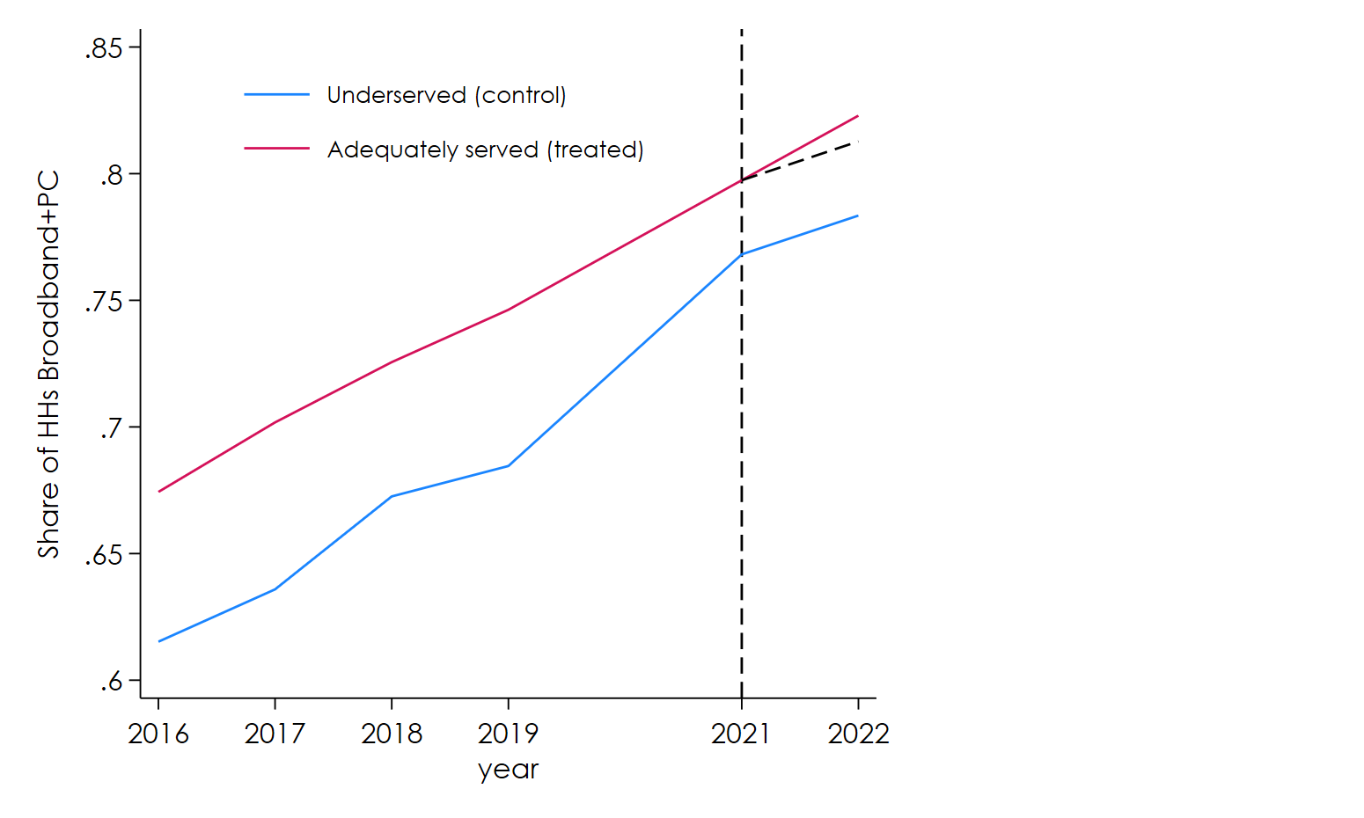

Figure 2: Broadband + PC adoption in low-income counties (observed means), 2016-2022 (source: ACS 1-year estimates).

Table 3 presents average treatment effect (ATE) estimates, with controls for total population, income, education, and age. The table presents estimates for two different specifications. Model 1 is a standard two-way specification with county-year fixed effects, while model 2 is a triple difference specification that replicates the empirical strategy used by Zuo (2021).[5] A key difference is that the treatment variable (the supply of fixed broadband) is a binary factor in model 1 (and thus indicates a comparison between underserved and well-served counties), while in model 2 it enters the model as a continuous variable (i.e., as the share of locations in a county served by fixed broadband). In addition, notice the sample size is significantly larger in model 2 as this specification uses information for all counties in our sample for which ACS 1-year information is available (1,921 counties), whereas model 1 is restricted to low-income counties with a threshold set at $50,000/year.

The results indicate that the ACP program resulted in an increase of between 6 and 10 percentage points in broadband and PC adoption in low-income counties adequately served by fixed broadband, relative to underserved counties. Taking the more conservative estimate in model 1, this represents an increase of about 7% relative to the average adoption level in adequately served counties in 2021 (79.7%), the period immediately before treatment. Because of the relatively small sample size and the limitations in the ACS data (particularly the fact that only a single post-treatment data point is available), model 1 results are statistically significant at lower confidence levels than usual. Due to these limitations, results must be interpreted as indicative.

*Table 3: Average treatment effect of ACP on broadband and PC adoption*

|  |  |  |
| --- | --- | --- |
|  | (1) | (2) |
|  | Double difference specification | Triple difference specification |
| **Average treatment effect (% broadband+PC)** | **0.0572\***  **(0.0345)** | **0.0984\*\*\***  **(0.0307)** |
|  |  |  |
| Demographic controls | Yes | Yes |
| Observations | 1,471 | 11,366 |
| Number of counties | 237 | 1,921 |

Wild bootstrap standard errors (model 1) and robust standard errors (model 2) in parentheses.

*** p<0.01, ** p<0.05, * p<0.1

Appendix B presents a robustness check for these results with an event study formulation in which a model 1 is estimated separately for each year, with 2021 (the last pre-treatment year) being the omitted comparison period. This is akin to a placebo test, in which the main result is evaluated in each pre and post treatment period separately. The results provide further validation that the observed impact of ACP only manifests in the post-treatment period (year 2022).

1. Conclusion

Suppose the federal government started a program that offered vouchers to low-income households to buy fresh fruits and vegetables. Such a program, valuable as it would be, is likely to have very limited benefits for households in so-called “food deserts” (which are disproportionately low-income areas), given the inadequate availability of fresh fruits and vegetables at local stores.[6] This study uses a similar premise to evaluate the impact of the ACP program, comparing broadband and PC adoption in low-income counties adequately supplied by fixed broadband operators to similarly low-income counties where the availability of fixed services is limited.

Overall, the results indicate that ACP has had a positive impact in fixed broadband and PC uptake among low-income households. The magnitude of the effect varies across models, depending on the specification and the sample of counties used. In the difference-in-difference estimations, which are more robust to baseline differences and other confounders, the effect size is between 6 and 10 percentage points above and beyond the expected adoption rate had ACP not been launched (Table 3). While the low statistical significance in model 1 and the variations in effect size deserve further examination, the different specifications and the robustness check generally validate the main results.

Given the scale of the ACP program, do these findings point to relatively modest impacts? Quite to the contrary, we believe these effects are surprisingly large given the context and the goals of the program. First, it is important to note that broadband and PC adoption levels were relatively high at the time ACP was launched in early 2022 - in the 75-80% range, depending on the sample of counties (see Figure 2). Research shows that, as more households are connected, it is increasingly difficult to close the remaining gaps because of the complex interplay of affordability barriers with other factors related to digital literacy, housing instability and others. Second, as federal policymakers and analysts have noted, the goal of the ACP program was not simply to bring new households online, but more broadly to sustain the progress made in connecting low-income households during the COVID-19 pandemic.[7] As such, a key goal of ACP was to alleviate the cost burden of connectivity for vulnerable households, which research shows tend to experience fluctuations in connectivity that depend on economic conditions and other factors.[8]

A key takeaway from this study is the complementarity between demand-side support programs such as ACP and supply-side programs such as BEAD. Without adequate service availability and robust competition on price and quality, the impact of demand-side support programs is severely limited. At the same time, without ACP support many middle and low-income households are likely to find the services offered by BEAD recipients unaffordable, threatening their economic sustainability. This is why programs such as ACP will be necessary in the foreseeable future, and why its expiration is likely to have ripple effects across other digital equity efforts.

*Appendix A*

Our main estimates are premised on identifying low-income counties where a majority of households is eligible to receive ACP benefits. To test different income thresholds, we use ACS microdata to estimate the share of ACP-eligible households for counties in several states across different median income thresholds (Figure 3). As expected, the lower the threshold the higher the share of ACP-eligible households. At the same time, a lower median income threshold yields a smaller sample of low-income counties, and thus a trade-off must be made between precision (in terms of capturing ACP-eligible households) and sample size.

Our preferred threshold is $50,000/year. This threshold yields a reasonable large sample of counties (n=237) in which a vast majority of households are eligible to receive ACP benefits. The figure below illustrates this in four states (California, Texas, Ohio and Alabama), ranging from high to low income. As shown, in counties below $50,000/year about 80% of households are ACP-eligible, with only small variations by state. This means that, using this threshold, only a small fraction of households in counties considered “treated” would be ineligible to receive ACP benefits.

Figure 3: Share of ACP-eligible HHs using different low-income thresholds in selected states (source: 2022 ACS 1-year estimates).

Appendix B

The event study plot below offers a placebo test of the main DiD results by testing the impact of the “treatment” (the launch of ACP in 2022) in each pre and post treatment period separately. The coefficients are similar to model 1 in Table 3 (double difference estimator using the $50,000/year threshold), except that each year is evaluated separately against 2021, the last pre-treatment period (denoted -1 in the plot, which by definition has a coefficient of zero). Because 2020 ACS 1-year data is not available, no results exist for the second lag year (-2 in the plot). The results validate the main findings, showing that statistically significant differences in broadband and PC adoption between underserved and served low-income counties only manifest after the launch of ACP in 2022 (year 0 in the plot).

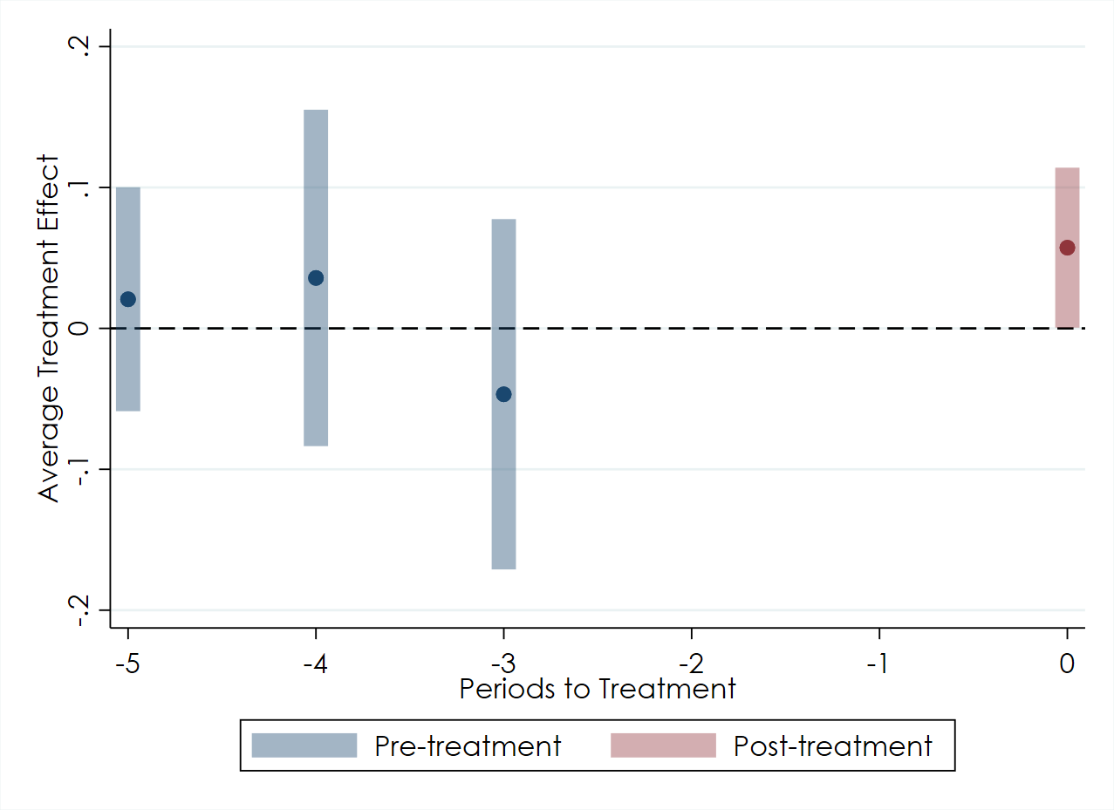

Figure 4: ATE estimates from model 1 in Table 3 by year, 2021 is the omitted comparison period (90% confidence intervals)

1. See, among others, Hauge, Janice A., Mark A. Jamison, and R. Todd Jewell. “Discounting Telephone Service: An Examination of Participation in the Lifeline Assistance Program Using Panel Data.” Information Economics and Policy 20, no. 2 (2008): 135–49. doi.org/10.1016/j.infoecopol.2007.12.002.
2. For details about the FCC broadband map data collection and the definition of serviceable location see <https://help.bdc.fcc.gov>. It is worth noting that the maps are known to overestimate the availability of services, and have been challenged by several states and advocacy organizations (<https://arstechnica.com/tech-policy/2023/01/fccs-new-broadband-map-greatly-overstates-actual-coverage-senators-say>).
3. For example, Rosston and Wallsten (2020) and Zuo (2021) use DiD to estimate the impact of Comcast’s low-cost broadband plan (Internet Essentials). Similarly, Galperin (2022) uses DiD to evaluate the outcome of affordable plans by Comcast, AT&T and Frontier in California.
4. Due to the COVID-19 pandemic, ACS 1-year estimates for 2020 are not available.
5. Zuo, George W. 2021. "Wired and Hired: Employment Effects of Subsidized Broadband Internet for Low-Income Americans." American Economic Journal: Economic Policy, 13 (3): 447-82.
6. These programs in fact exist at the state level. For example, the CalFresh fruit and vegetable EBT Pilot Project was launched in California in 2018 and offers a refund of up to $60/month to food assistance recipients when benefits are used to buy fresh fruits and vegetables (see https://www.cdss.ca.gov/inforesources/ebt/california-fruit-vegetable-ebt-pilot-project).
7. See Horrigan (2023). https://www.benton.org/blog/gain-and-sustain-affordable-connectivity-program-getting-more-people-online.
8. See for example Gonzales, A.L. (2016). From Internet access to Internet maintenance: A new approach to the US Internet divide. Information, Communication, and Society, 19, 2, 234-248.